Comparative video analysis of bowling and throwing actions

Dr Rene E. D. Ferdinands, Uwe Kersting
Some of the world's leading research on elbow angle in cricket bowling is conducted at the University of Waikato (Department of Physics & Electronic Engineering) and the University of Auckland (Biomechanics Laboratory) in New Zealand. They published the first laboratory studies that examined the elbow angle characteristics of bowlers across all speed groups, including spin bowlers (Ferdinands & Kersting, 2004). Their research shows that the bowling law in cricket had been largely inadequate in defining what constitutes a fair delivery. However, their latest research is now revealing that the specification of an elbow extension angle tolerance by itself is not sufficient to determine the legality of a bowling action.
The ICC Regulations for the Review of Bowlers Reported with Suspected Illegal Bowling Actions sets an allowable maximum of 15 degrees elbow extension for all bowlers and types of deliveries (www.icc-cricket.com/rules). The measurement of elbow extension is from the forearm relative to the upper arm to the straight position. Elbow hyperextension or adduction is not included in the 15-degree tolerance threshold. However, in extensive 3D laboratory testing of 69 bowlers using 8 motion analysis high resolution cameras with frame rates of 240 Hz, it was found that a class of bowlers was able to produce a bowling action that exhibited throwing-type characteristics, but still remained within the legal 15-degree tolerance threshold. These bowlers were referred to as "throwers" or "jerkers". They restricted their elbow extension to less than 15° from shoulder height to ball release, but extended their elbows rapidly at greater than 150°/s through release, i.e. they continued to extend their elbows after release, so that the maximum point of extension occurred after release (Video 1 & Figure 2). Such a motion resembles a throwing-like action: the elbow is flexed at release, which means that humerus internal rotation has the potential to contribute to ball release velocity (Ferdinands and Marshall, 2003). Also, as in a throw, the elbow extends after ball release. In the legal bowling action either the elbow extends prior to or at release, or extends after release with an elbow extension rate of less than 150°/s (Video 1 & Figure 1). There is less potential contribution of humerus internal rotation to ball release speed, and the action aesthetically resembles a "bowl". For a more comprehensive presentation of the data refer to the ISBS CIS article "The Biomechanics of Illegal Bowling Actions in Cricket".

Video: (Top and bottom left) Front and side perspectives of a legal bowling action. An elbow extension of less than 15° is completed from the time the bowling arm is at shoulder height (Frame 11) to the time of ball release (Frame 25). (Top and bottom right) Front and side perspectives of a "jerking" action, which has throwing-type characteristics, but is still legal under the 15° elbow extension angle law. The elbow only extends 12.6° from the time the bowling arm is at shoulder height (Frame 11) to the time of ball release (Frame 29). However, after ball release there is rapid elbow extension occurring at a rate of 953.4°/s. The "jerker" extends a flexed arm through release as in a throw.
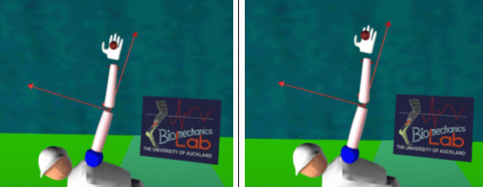
Figure 1: The bowling arm of the legal bowler one frame prior to ball release (left), and one frame after release (right).
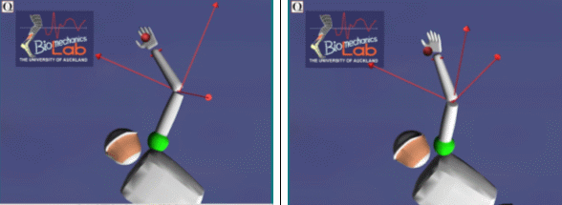
Figure 2: The flexed bowling arm of the suspect "jerking" bowler just one frame prior to ball release (left). The elbow is rapidly extended through and after release as in a throwing-type motion (right). Note that it is difficult to represent the exact time of ball release on the animation.

